Python Practice sets

# Fundamental datatypes:

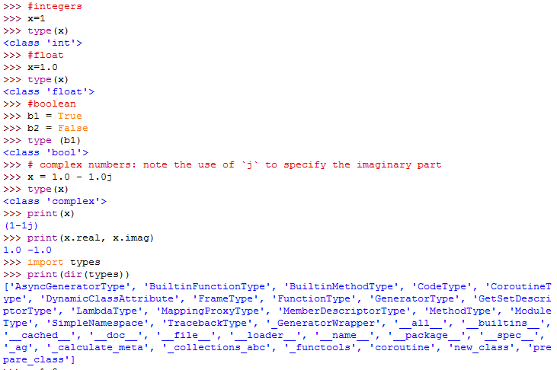

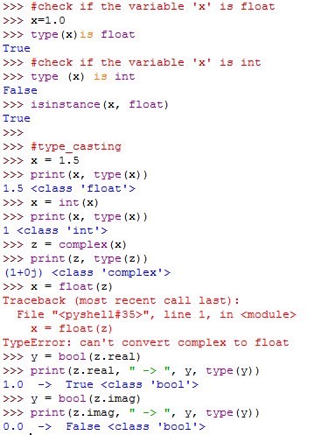

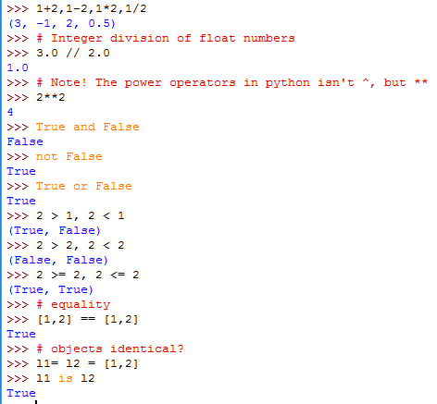

# Traffic light Example :

## (if else if conditions)

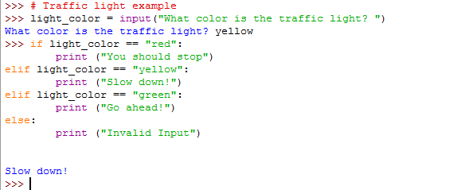

# Raw_input practice:

# 

# Problem Question:

# **Create a program that asks the user to enter their name and their age. Print out a message addressed to them that tells them the year that they will turn 100 years old.**

# Solution:

